Web Design Project

Narrative: This website’s goal is to tell the viewer about myself, show them my relevant projects, show them my resume, and give them a way to contact me. The target audience is future employers. This website starts with a photo of me fishing and has a navigation tab at the bottom to my bio, resume, projects, and a contact page. The bio page gives a brief description of myself and my schooling, and where I’m from. The Resume page shows a png file of my resume. The projects page has a table including projects that I think best show my current abilities. The contact page has a web form that emails me a message from the viewer and links to other forms of contacting me.

Usability Testing: Madelyn Edwards - “I think the resume should be the full width of the page so you can read it easier and I prefer things that are centered but this is very left aligned” – I ended up changing this after the fact.

Summary:

1. The primary differences I can see from writing your own code for a website and using a development service is that in a development service, everything is visualized for you. Making it so you don’t have to type in all of the tags and styling terms but instead pick what you want and put it where you want.
2. An advantage of building your own site with code is that you can manipulate anything into anything as long as you know the right code to do it with. You get to pick everything down to the finite detail. A disadvantage is that it takes a lot of skill and know how to get a site just how you want it. I’ve been doing this class for 5 months now and I feel like I’ve barely scratched the surface of what you can do with CSS, JavaScript, and HTML. Makes it harder for the average joe to make their website go the extra step.
3. The advantage and disadvantages of a web development service are opposite of writing your own code for a website. The advantage of a web development service is that any average joe could figure out how to make a complex website without doing a ton of research and trial and error. While the disadvantage is that you can’t get into the finite details of the site. You’re limited to what the platform allows you to do.

Validation:

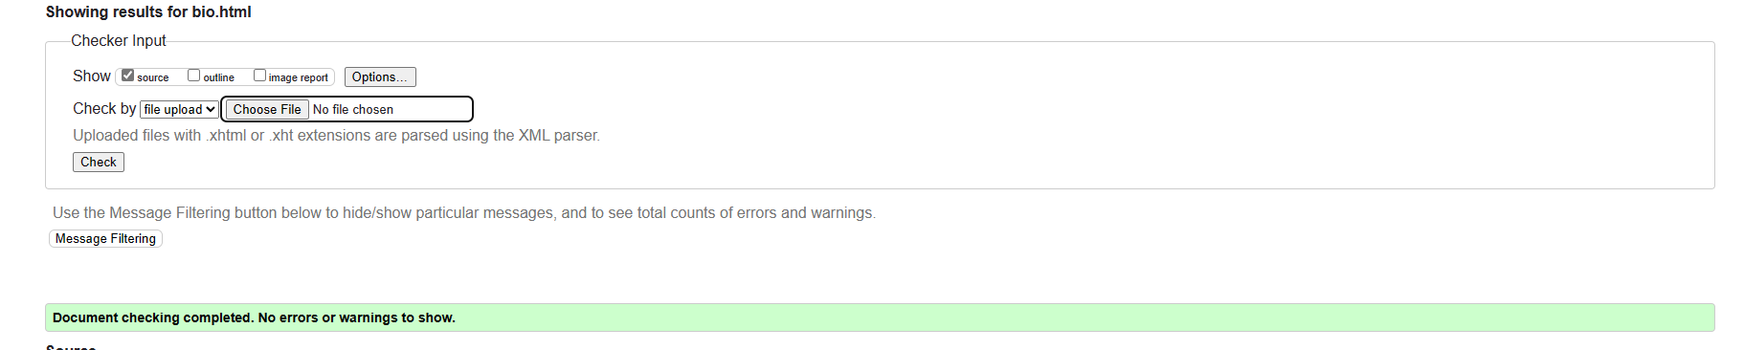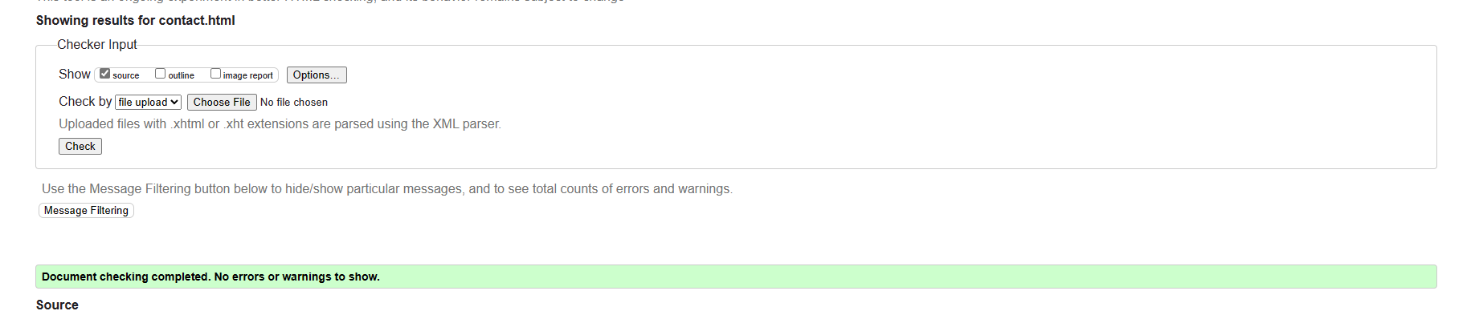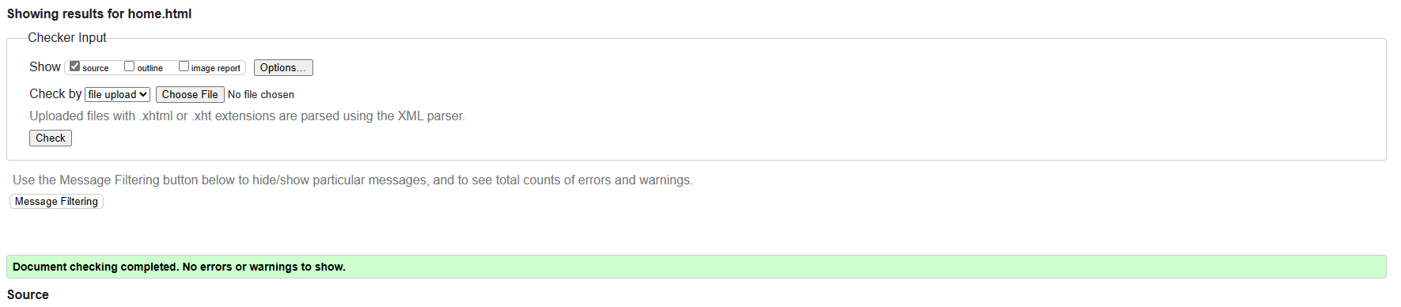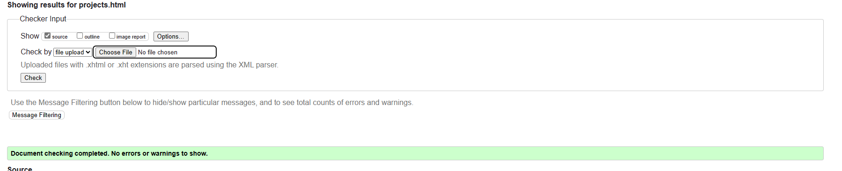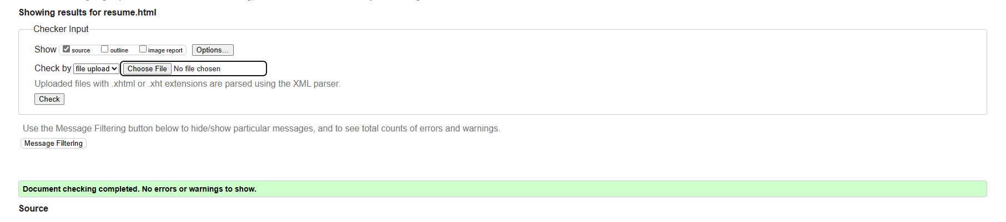

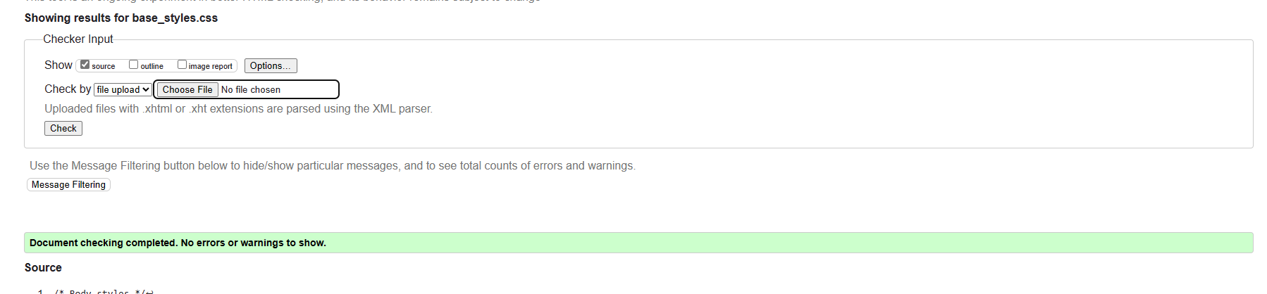

Navigation:

Camerons Portfolio

Navigational Links

home.html

* bio.html
* resume.html
* projects.html
* contact.html

